**PRACTICAL 3**

Calculation of BMI

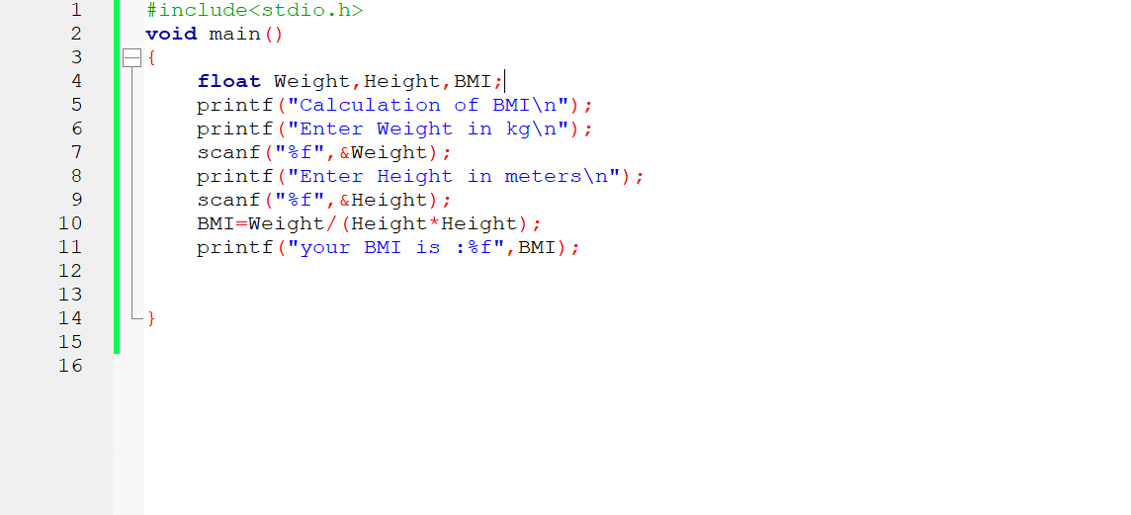

* Here we are calculating the BMI (Body Mass Index) of a person.
* Weight is measured in Kilograms.
* Height is measured in Meters.
* BMI is Weight/Height2
* Here we are using %f as we used float variable type.

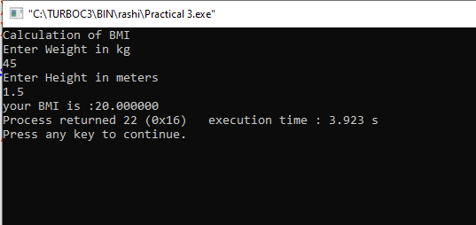

This program is prepared by

Domadiya Rashi Jayesh – 25TCEILX